**Assignment 24.4**

**Dataset:**

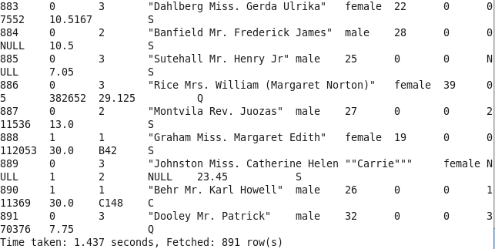

**Average age of people who died**

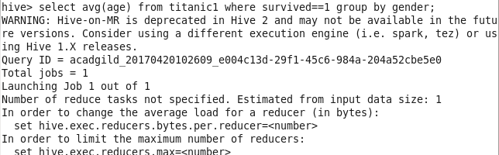

**Output:**

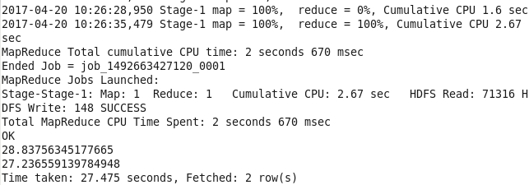

**Count of people who died/survived:**

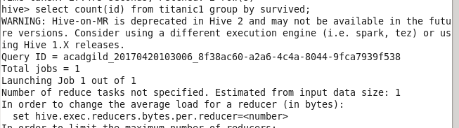

**Output:**

